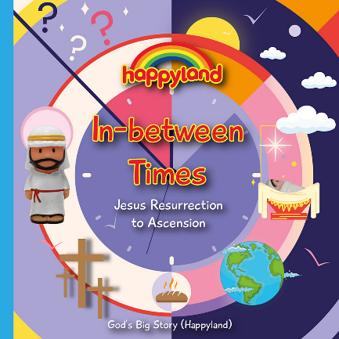
Tick Tock, Tick Tock,
What Time is on God’s Clock?

Hickory dickory dock,
What time is on God’s clock?
God made the world,
And it was good.
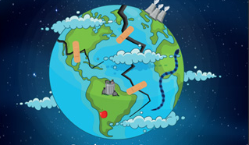
Tick tock, tick tock, tick tock.

Hickory dickory dock,
What time is on God’s clock?
We break the world,
God has a plan.
Tick tock, tick tock, tick tock.
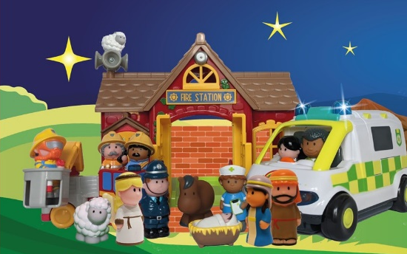
Hickory dickory dock,
What time is on God’s clock?
God sends Jesus,
To rescue us.
Tick tock, tick tock, tick tock.

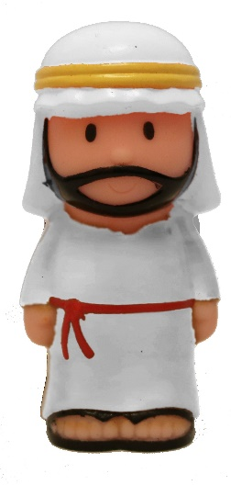
Hickory dickory dock,
What time is on God’s clock?
Jesus on earth,
Points us to God.
Tick tock, tick tock, tick tock.

Hickory dickory dock,
What time is on God’s clock?
Jesus has died,
He’s in the tomb.
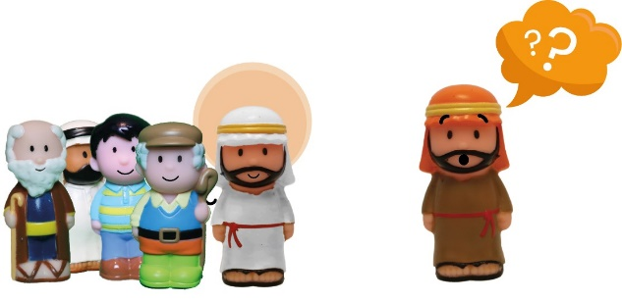
Tick tock, tick tock, tick tock.

Hickory dickory dock,
What time is on God’s clock?
Jesus alive,
Hip, hip hooray!
Tick tock, tick tock, tick tock.
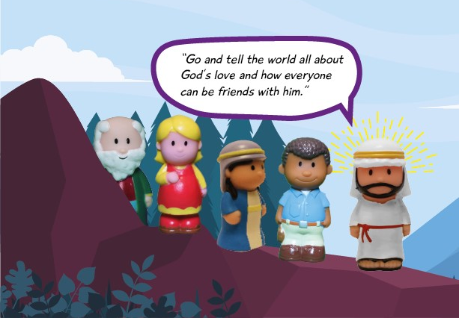
Hickory dickory dock,
What time is on God’s clock?
Jesus goes back,
To God in heaven.
Tick tock, tick tock, tick tock.

Hickory dickory dock,
What time is on God’s clock?
We’re waiting now
For Jesus to come
Tick tock, tick tock, tick tock.

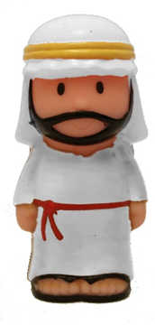
Tick tock, tick tock, tick tock,
What time is on God’s clock?
Jesus comes back,
To fix the world.
Tick tock, tick tock, tick tock.

